CAS PY 106

Pre-session Note 4

Field = zero

1. Opposite directions
2. 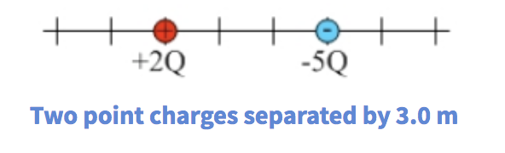
3. Regions the two electric fields are in opposite directions
4. Left of 2Q charge 🡪 2Q charge receives the charge and -5Q charge gives charge (opposite)
5. In between 🡪 2Q charge receives charge and -5Q charge gives charge (same direction)
6. Right of 2Q charge 🡪 2Q charge receives charge and -5Q charge gives charge (opposite)
7. Equal in magnitude and opposite direction
8. Left of 2 Q charge (Assume E = 0)
9. Left of 2Q charge, the two fields are in opposite directions and there is only one point the field cancel in that region because -5Q charge, which is further away from the 2Q charge, has a greater magnitude.
10. Mathematical:

E = kQ/r^2

E = k\*(2Q)/r^2 + k\*(-5Q)/(r+3)^2

0 = k\*(2Q)/r^2 + k\*(-5Q)/(r+3)^2

0 = 2kQ/r^2 – 5kQ/(r^2+6r+9)

2/r^2 = 5/(r^2+6r+9)

2r^2 + 12r + 18 = 5r^2

3r^2 – 12r – 18 = 0

r^2 – 4r – 6 = 0

Quadratic equation: (4+- (16+24)^.5)/2 🡪 2+-(10)^.5 🡪 x = 5.16 or -1.16 but -1.16 does not make sense

At 5.16 left of 2Q charge, the magnitude is equal

1. Between two charges

Same direction (can never be 0)

1. Right of -5Q charge (Assume E = 0)
2. Because the point right of -5Q charge is closer to the -5Q charge, the field from -5Q charge is always greater than the field from 2Q charge. Therefore, the net field can never be zero.
3. Mathematical:

E = kQ/r^2

E = k(2Q)/(r+3)^2 + k(-5Q)/r^2

2/(r+3)^2 = 5/r^2

2r^2 = 5r^2 + 30r + 45

0 = 3r^2 + 30r + 45

0 = r^2 + 10r + 15

r = -1.84 or -8.16

Both values are negative so they both do not make sense

No magnitude is equal at right of -5Q charge